LIST OF EXPERIMENTS

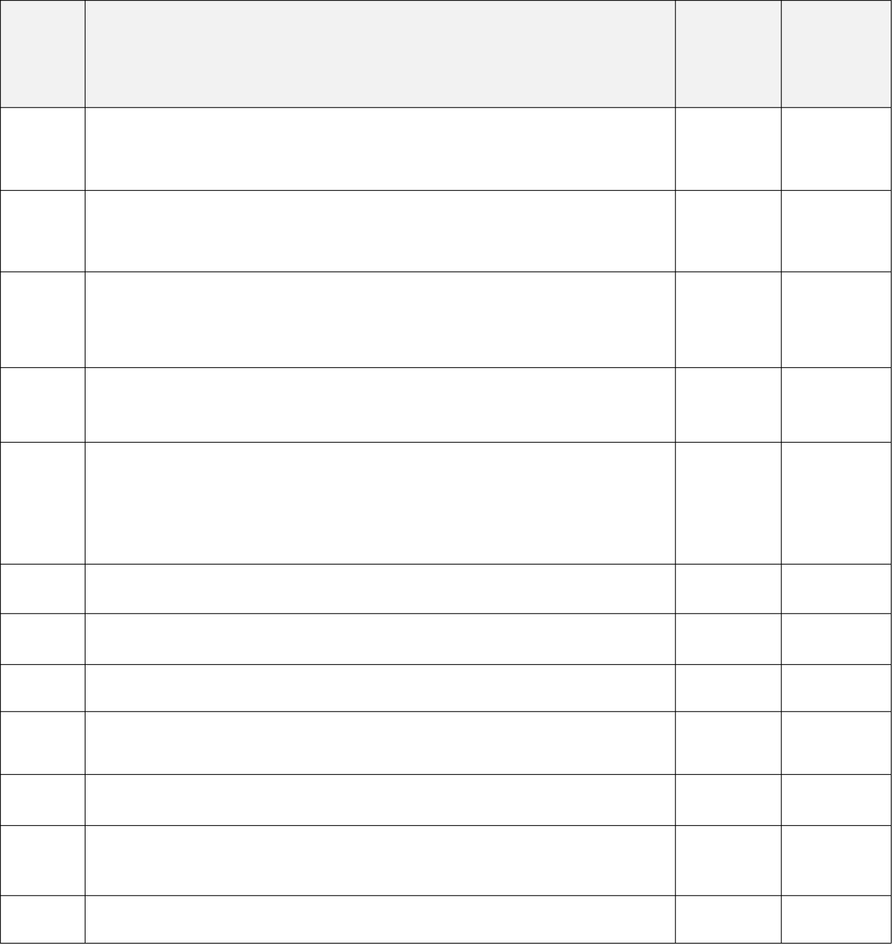**Operating System**

|  |  |  |
| --- | --- | --- |
|  | **Date** | **Instructor Signature** |
| **S.no** | **Lab Experiments** |
| 1 | Process System Calls   * Overview of Kernel mode and User mode * Implementation of DOS-command (Internal and External). |  |
| 2 | IO System Calls   * Implementations of file Create, Open, Close, Read and write in Python. |  |
| 3 | First Come First Serve Scheduling   * Implementations of first co me first serve in Python. * Manipulate and find Waiting time, turnaround time, average wait time and average turnaround time. |  |
| 4 | Shortest job first Scheduling   * Implementation of Non-preemptive SJF in Python. * Implementation of preemptive SJF in Python. |  |
| 5 | Priority Scheduling   * Implementation of preemptive priority scheduling on   different arrival time in Python.   * Implementation of non-preemptive priority scheduling in Python. |  |
| 6 | Round Robin Scheduling   * Implementation of Round Robin scheduling in Python. |  |
| 7 | Flags in Operating System   * Implementation of flags and analyze output |  |
| 8 | Producer-consumer problem Using semaphores   * Implementation of Producer-consumer problem in Python. |  |
| 9 | Memory Management   * Implementation of First, Next, Best and Worst fit in Python |  |
| 10 | File Manipulation   * Implementation of file manipulation in Python. |  |
| 11 | Simulate Page Replacement Algorithms FIFO, LRU and Optimal   * Implementation of FIFO, LRU and optimal page replacement in Python. |  |
| 12 | Banker Algorithm For Deadlock Prevention   * Implementation of Banker algorithm in Python. |  |